OFFLINE ACTIVITY · YEAR 8 SCIENCE · AC9S8U03

Map the edges.
About 50 minutes · In pairs, one map between two · Pencil, ruler, red, orange and green pencils
No one has ever seen the edge of a tectonic plate. Geologists found the edges by plotting where the ground shakes and where volcanoes erupt, and the pattern that came out is some of the strongest evidence there is for plate tectonics. Here you do the same thing with 28 real earthquakes and 10 volcanoes from around the Australian Plate, then explain what the pattern means.

What to do
- Predict. Before you plot anything, draw a dashed pencil line on the map where you think the edges of the Australian Plate run. Do not rub it out later. You will compare it with the data.
- Plot the earthquakes. Work in pairs on one map. One of you plots the odd-numbered earthquakes, the other the even-numbered ones. Find each one’s latitude and longitude, draw the symbol for its depth, and write its number next to it.
- Plot the volcanoes as small red stars. Five each.
- Observe. Step back and look. Where do the symbols line up? Draw a line along each line-up and colour it: red where the edge is convergent, orange where it is transform, green where it is divergent. Label the four edges with the names from the lesson: Sunda Trench, Tonga-Kermadec Trench, Alpine Fault, Southeast Indian Ridge.
- Explain. Answer the questions, then write your paragraph.

The symbols
- ● shallow earthquake, 0 to 70 km deep
- ▲ intermediate, 70 to 300 km deep
- ■ deep, more than 300 km
- ★ volcano, drawn in red
- ▬ convergent edge ▬ transform edge ▬ divergent edge

Reading the coordinates
19.8°S 133.9°E means 19.8 degrees south of the equator and 133.9 degrees east of the Greenwich line. Find the latitude on the side of the map and the longitude along the bottom. The small ticks on the frame mark every 5 degrees, and plotting to the nearest degree is close enough.
A few places are past the 180° line, so their longitude is given as W, for west. 177.2°W sits a little to the right of the 180° line, between 180° and 170°W.

The earthquakes
No. | Date (UTC) | Where | Latitude | Longitude | Depth (km) | Magnitude | Symbol
1 | 14 Oct 1968 | Meckering, Western Australia | 31.6°S | 117.1°E | 11 | 6.5 | ●
2 | 22 Jan 1988 | Tennant Creek, Northern Territory | 19.8°S | 133.9°E | 5 | 6.7 | ●
3 | 27 Dec 1989 | Newcastle, New South Wales | 33.0°S | 151.6°E | 10 | 5.4 | ●
4 | 17 Jun 1996 | Flores Sea, north of Flores, Indonesia | 7.1°S | 122.6°E | 587 | 7.9 | ■
5 | 19 Aug 2002 | South of Fiji | 23.9°S | 178.5°E | 675 | 7.7 | ■
6 | 25 Jul 2004 | Under southern Sumatra, Indonesia | 2.4°S | 104.0°E | 582 | 7.3 | ■
7 | 23 Dec 2004 | Macquarie Island region | 49.3°S | 161.3°E | 10 | 8.1 | ●
8 | 26 Dec 2004 | Off Sumatra (Aceh), Indonesia | 3.3°N | 96.0°E | 30 | 9.1 | ●
9 | 17 Jul 2006 | South of Java, Indonesia | 9.3°S | 107.4°E | 20 | 7.7 | ●
10 | 1 Apr 2007 | Solomon Islands | 8.5°S | 157.0°E | 24 | 8.1 | ●
11 | 8 Aug 2007 | Under Java, near Jakarta, Indonesia | 5.9°S | 107.4°E | 280 | 7.5 | ▲
12 | 9 Dec 2007 | South of Fiji | 26.0°S | 177.5°W | 153 | 7.8 | ▲
13 | 8 Dec 2008 | Southeast Indian Ridge | 53.0°S | 106.8°E | 11 | 6.3 | ●
14 | 29 Sep 2009 | Samoa and Tonga | 15.5°S | 172.1°W | 18 | 8.1 | ●
15 | 7 Oct 2009 | Vanuatu | 12.5°S | 166.4°E | 35 | 7.8 | ●
16 | 10 Nov 2010 | Southeast Indian Ridge | 45.5°S | 96.4°E | 10 | 6.5 | ●
17 | 21 Feb 2011 | Christchurch, New Zealand | 43.6°S | 172.7°E | 6 | 6.1 | ●
18 | 23 May 2013 | Tonga | 23.0°S | 177.2°W | 174 | 7.4 | ▲
19 | 1 Jan 2016 | Ridge south of Australia | 50.6°S | 139.4°E | 10 | 6.3 | ●
20 | 20 May 2016 | Petermann Ranges, Northern Territory | 25.6°S | 129.9°E | 10 | 6.0 | ●
21 | 13 Nov 2016 | Kaikōura, New Zealand | 42.7°S | 173.1°E | 15 | 7.8 | ●
22 | 22 Jan 2017 | Bougainville, Papua New Guinea | 6.2°S | 155.2°E | 135 | 7.9 | ▲
23 | 25 Feb 2018 | Highlands, Papua New Guinea | 6.1°S | 142.8°E | 25 | 7.5 | ●
24 | 19 Aug 2018 | Fiji | 18.1°S | 178.2°W | 600 | 8.2 | ■
25 | 24 Jun 2019 | Banda Sea, Indonesia | 6.4°S | 129.2°E | 212 | 7.3 | ▲
26 | 4 Mar 2021 | Kermadec Islands | 29.7°S | 177.3°W | 29 | 8.1 | ●
27 | 16 Apr 2025 | Southeast Indian Ridge | 47.8°S | 99.6°E | 10 | 6.6 | ●
28 | 14 Aug 2026 | Flores, near Ende, Indonesia | 8.3°S | 121.3°E | 10 | 7.8 | ●

The volcanoes
No. | Volcano | Country | Latitude | Longitude | Last eruption
V1 | Krakatau | Indonesia | 6.1°S | 105.4°E | 2023
V2 | Merapi | Indonesia | 7.5°S | 110.4°E | 2026
V3 | Agung | Indonesia | 8.3°S | 115.5°E | 2022
V4 | Manam | Papua New Guinea | 4.1°S | 145.0°E | 2026
V5 | Rabaul | Papua New Guinea | 4.2°S | 152.2°E | 2014
V6 | Yasur | Vanuatu | 19.5°S | 169.4°E | 2026
V7 | Hunga Tonga-Hunga Ha'apai | Tonga | 20.6°S | 175.4°W | 2022
V8 | Whakaari / White Island | New Zealand | 37.5°S | 177.2°E | 2026
V9 | Heard Island (Big Ben) | Australia | 53.1°S | 73.5°E | 2026
V10 | Newer Volcanics Province (Mount Gambier area) | Australia | 37.8°S | 142.5°E | about 5,000 years ago
Earthquakes: United States Geological Survey earthquake catalogue (ComCat), locations, depths and magnitudes as listed there, selected from the largest events in each area since 1960. Dates are in universal time (UTC), so a few differ by a day from the local date: Christchurch’s earthquake was 22 February 2011 in New Zealand. Volcanoes: Smithsonian Institution Global Volcanism Program.

Map the edges. The Australian Plate and its neighbours. Dashed pencil line first: your prediction. Names: ______________________________
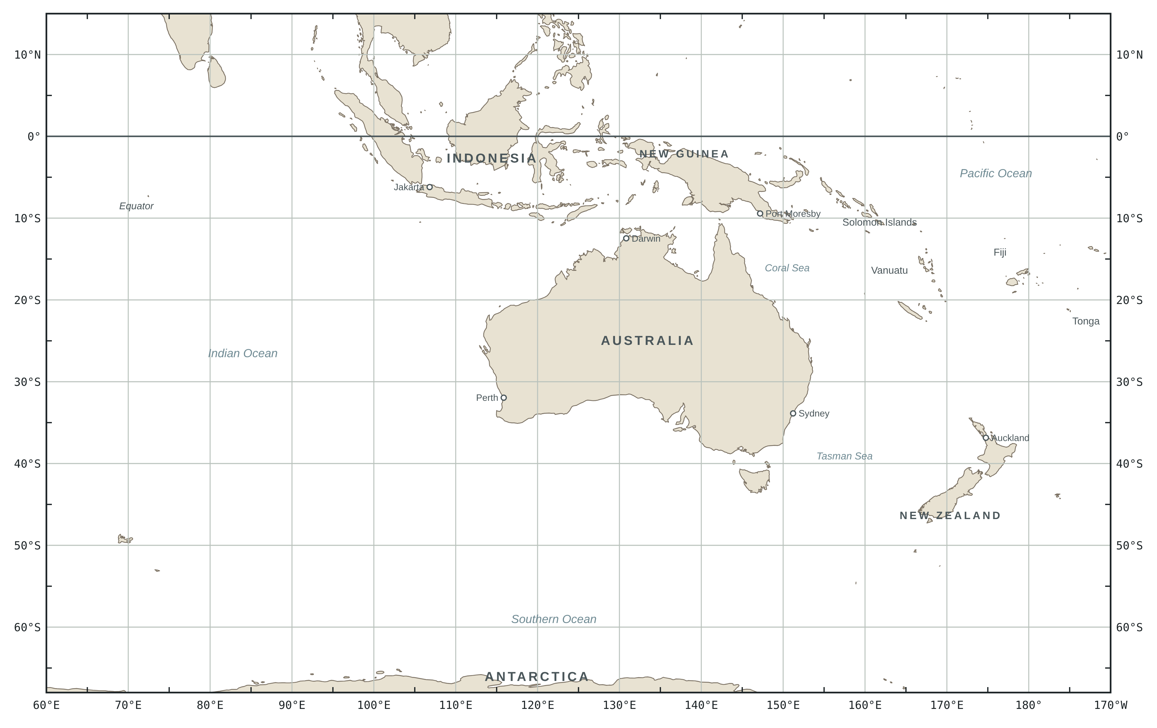
● shallow, 0 to 70 km ▲ intermediate, 70 to 300 km ■ deep, more than 300 km ★ volcano ▬ convergent ▬ transform ▬ divergent

Read the pattern
1 Compare your dashed prediction with the pattern. Where was it close, and where did the data surprise you?

2 Two trenches. At the Sunda Trench and the Tonga-Kermadec Trench the shallow earthquakes lie along the trench and the intermediate and deep ones lie off to one side. Which side, for each trench? The earthquakes happen inside the sinking plate as it goes down, so what does this tell you about which plate is sliding under the other?

3 Volcanoes. Are the volcanoes on the trenches themselves or to one side? Which side, and roughly how far away in degrees? Why do they form there and not on the trench?

4 The ridge. Compare the Southeast Indian Ridge earthquakes with the trench earthquakes: how deep, how big. Are any volcanoes marked along the ridge? Explain the differences using what the plates are doing there.

5 New Zealand. The earthquakes at Christchurch, Kaikōura and Macquarie Island are all shallow, and there are no volcanoes in the South Island. What kind of boundary fits that? Whakaari, in the North Island, is a volcano. What does that suggest about the boundary there?

6 The odd ones out. Tennant Creek, Meckering, Newcastle and the Petermann Ranges are nowhere near an edge, and neither are the volcanoes at Heard Island and Mount Gambier. Do they break the pattern? Suggest an explanation.

Explain
Your map is evidence. Use it to argue for the theory of plate tectonics: that Earth’s outer shell is broken into plates that move, and that earthquakes, volcanoes and mountains happen mostly where the plates meet.
Claim: one sentence.
Evidence. Three things your map shows. Point to specific earthquakes or volcanoes by number.
1.

2.

3.

Reasoning. Why does moving plates explain each piece of evidence? What would the map look like if the plates did not move?

One thing the pattern does not explain on its own (an anomaly, or a question you still have):

FOR THE TEACHER · NOT FOR STUDENTS

Notes and answers
Purpose
The paper version of the lesson’s predict, observe, explain. Students predict where the plate’s edges are, generate the evidence themselves by plotting real catalogue data, and explain the pattern. It stands on its own, or runs after Case 1 as the predict step for the rest of the series, or after all four cases as the synthesis.
Curriculum. AC9S8U03: “investigate tectonic activity including the formation of geological features at divergent, convergent and transform plate boundaries and describe the scientific evidence for the theory of plate tectonics”. The first elaboration is the activity itself: “examining patterns of earthquake and volcanic activity over time and proposing explanations”. Question 6 reaches “relating the extreme age and stability of a large part of the Australian continent to its plate tectonic history”. From the Year 8 achievement standard: students “apply an understanding of the theory of plate tectonics to explain patterns of change in the geosphere” and “analyse data and information to describe patterns, trends and relationships and identify anomalies”. (Australian Curriculum, Version 9.0, Science.)
Running it
- Predict 5 minutes, plot 20 minutes (14 earthquakes and 5 volcanoes each in the odd and even split), observe and colour 10 minutes, questions 15 minutes. The Explain page can be homework.
- Do one coordinate on the board first, and make it one of the W longitudes (number 14, 172.1°W). That is the step most students get wrong.
- Without coloured pencils, use a solid line for convergent, dashed for transform and dotted for divergent.
- Plotting to the nearest degree is fine. The pattern, not the precision, is the point.
- Students who finish early: add the earthquakes’ magnitudes as symbol sizes, or find today’s earthquakes on the USGS map and add them.
Answers
- 1. Most predictions hug the coast of Australia. The data put the northern edge in Indonesia and the eastern edge out past Fiji and Tonga, 3,000 km from the coast. The plate is far bigger than the continent, and the continent sits in the middle of it.
- 2. Sunda: the intermediate and deep earthquakes (11, 4, 6, 25) are north of the trench, under Sumatra, Java and the Flores and Banda seas, so the Australian Plate is sliding north under Indonesia. Tonga-Kermadec: they (12, 18, 5, 24) are west of the trench, under and beyond Fiji, so the Pacific Plate is sliding west under the Australian Plate. The deepest ones are farthest from the trench because the sinking plate goes down at an angle.
- 3. To one side, the same side as the deeper earthquakes, about 1.5 to 3 degrees (150 to 300 km) from the trench. They sit above the point where the sinking plate is about 100 km down and the water it carries lowers the melting point of the mantle above it. The trench itself is cold and nothing melts there.
- 4. Ridge earthquakes here are all shallow (about 10 km) and smaller (magnitude 6.0 to 6.6; the catalogue has nothing much above 7 on this ridge). No volcanoes are marked along it. The crust at a ridge is thin, hot and young, so faults cannot store as much energy, and the eruptions happen under 3 km of water. Heard Island is a hotspot volcano on the plate, not a ridge volcano.
- 5. A transform boundary: the plates slide past each other, so no plate sinks, nothing melts, no volcanoes, and the earthquakes are shallow because only the cold upper crust is brittle. Whakaari sits above the Hikurangi subduction zone, where the Pacific Plate sinks under the North Island, the southern continuation of the Tonga-Kermadec Trench. The convergent edge turns into the Alpine Fault across the South Island.
- 6. They are intraplate earthquakes and volcanoes, and they do not break the pattern: most earthquakes and nearly all the largest ones are at the edges, but the whole plate carries the stress of being pushed from the ridge and held up in the north, and old faults inside it slip now and then. Tennant Creek had three magnitude 6 earthquakes in one day in 1988; Meckering broke the ground surface in 1968; Newcastle was only magnitude 5.4 but shallow and under a city, and 13 people died. Heard Island sits on the Kerguelen hotspot. Mount Gambier belongs to the Newer Volcanics Province, which last erupted about 5,000 years ago from a source under south-east Australia that is still argued over.
- Explain. Claim: Earth’s surface is divided into moving plates and the Australian Plate is one of them. Evidence: earthquakes and volcanoes form lines, not a scatter (edges); the deep earthquakes lie to one side of each trench and get deeper away from it (a plate going down); volcanoes sit on the same side at a set distance (melting above the sinking plate); the ridge has only shallow, smaller earthquakes (plates pulling apart); the interior is nearly quiet (one rigid piece). Reasoning: fixed, unmoving crust would give either no pattern or a random one, and could not explain why depth and volcanoes are on one side only. Anomalies worth praising: the intraplate events, Heard Island, and the fact that the Tonga line and the Alpine Fault are the same two plates behaving differently.
About the data
- Magnitudes and depths are the USGS catalogue’s preferred values. Other agencies differ slightly: Geoscience Australia gives Tennant Creek 6.6 and Newcastle 5.6; GeoNet gives Christchurch 6.2. A depth of exactly 10 km in the catalogue usually means “shallow, not well resolved”, which is why the ridge events all read 10.
- The “Where” column is a plain description written for this sheet, not the catalogue’s place name. Numbers are in date order so that the odd and even halves each cover the whole region.
- Event IDs (earthquake.usgs.gov/earthquakes/eventpage/ followed by the ID): 1 iscgem815895, 2 usp0003c9n, 3 usp00043na, 4 usp0007jw8, 5 usp000ba6m, 6 usp000d0v4, 7 usp000db93, 8 official20041226005853450_30, 9 usp000ensm, 10 usp000f83m, 11 usp000fj6k, 12 usp000fu3q, 13 usp000gq70, 14 usp000h1ys, 15 usp000h2gd, 16 usp000hpc0, 17 usp000huvq, 18 usb000h3k3, 19 us10004ant, 20 us10005iyk, 21 us1000778i, 22 us10007uph, 23 us2000d7q6, 24 us1000gcii, 25 us600044zz, 26 us7000dflf, 27 us6000q6cs, 28 us6000tkt2
- Volcano numbers (volcano.si.edu): V1 262000, V2 263250, V3 264020, V4 251020, V5 252140, V6 257100, V7 243040, V8 241040, V9 234010, V10 259010
Sources
- U.S. Geological Survey, Earthquake Hazards Program. ANSS Comprehensive Earthquake Catalog (ComCat). earthquake.usgs.gov, accessed 25 October 2026.
- Global Volcanism Program, Smithsonian Institution. Volcanoes of the World database. volcano.si.edu, accessed 25 October 2026.
- Bird, P. (2003). An updated digital model of plate boundaries. Geochemistry, Geophysics, Geosystems, 4(3), 1027. The plate boundaries on the answer map.
- Natural Earth, 1:50 million land polygons, public domain. naturalearthdata.com.
- ACARA. Australian Curriculum, Version 9.0, Science, Year 8. australiancurriculum.edu.au.

Answer map. Numbers match the table. Plate boundaries after Bird (2003). For the teacher.
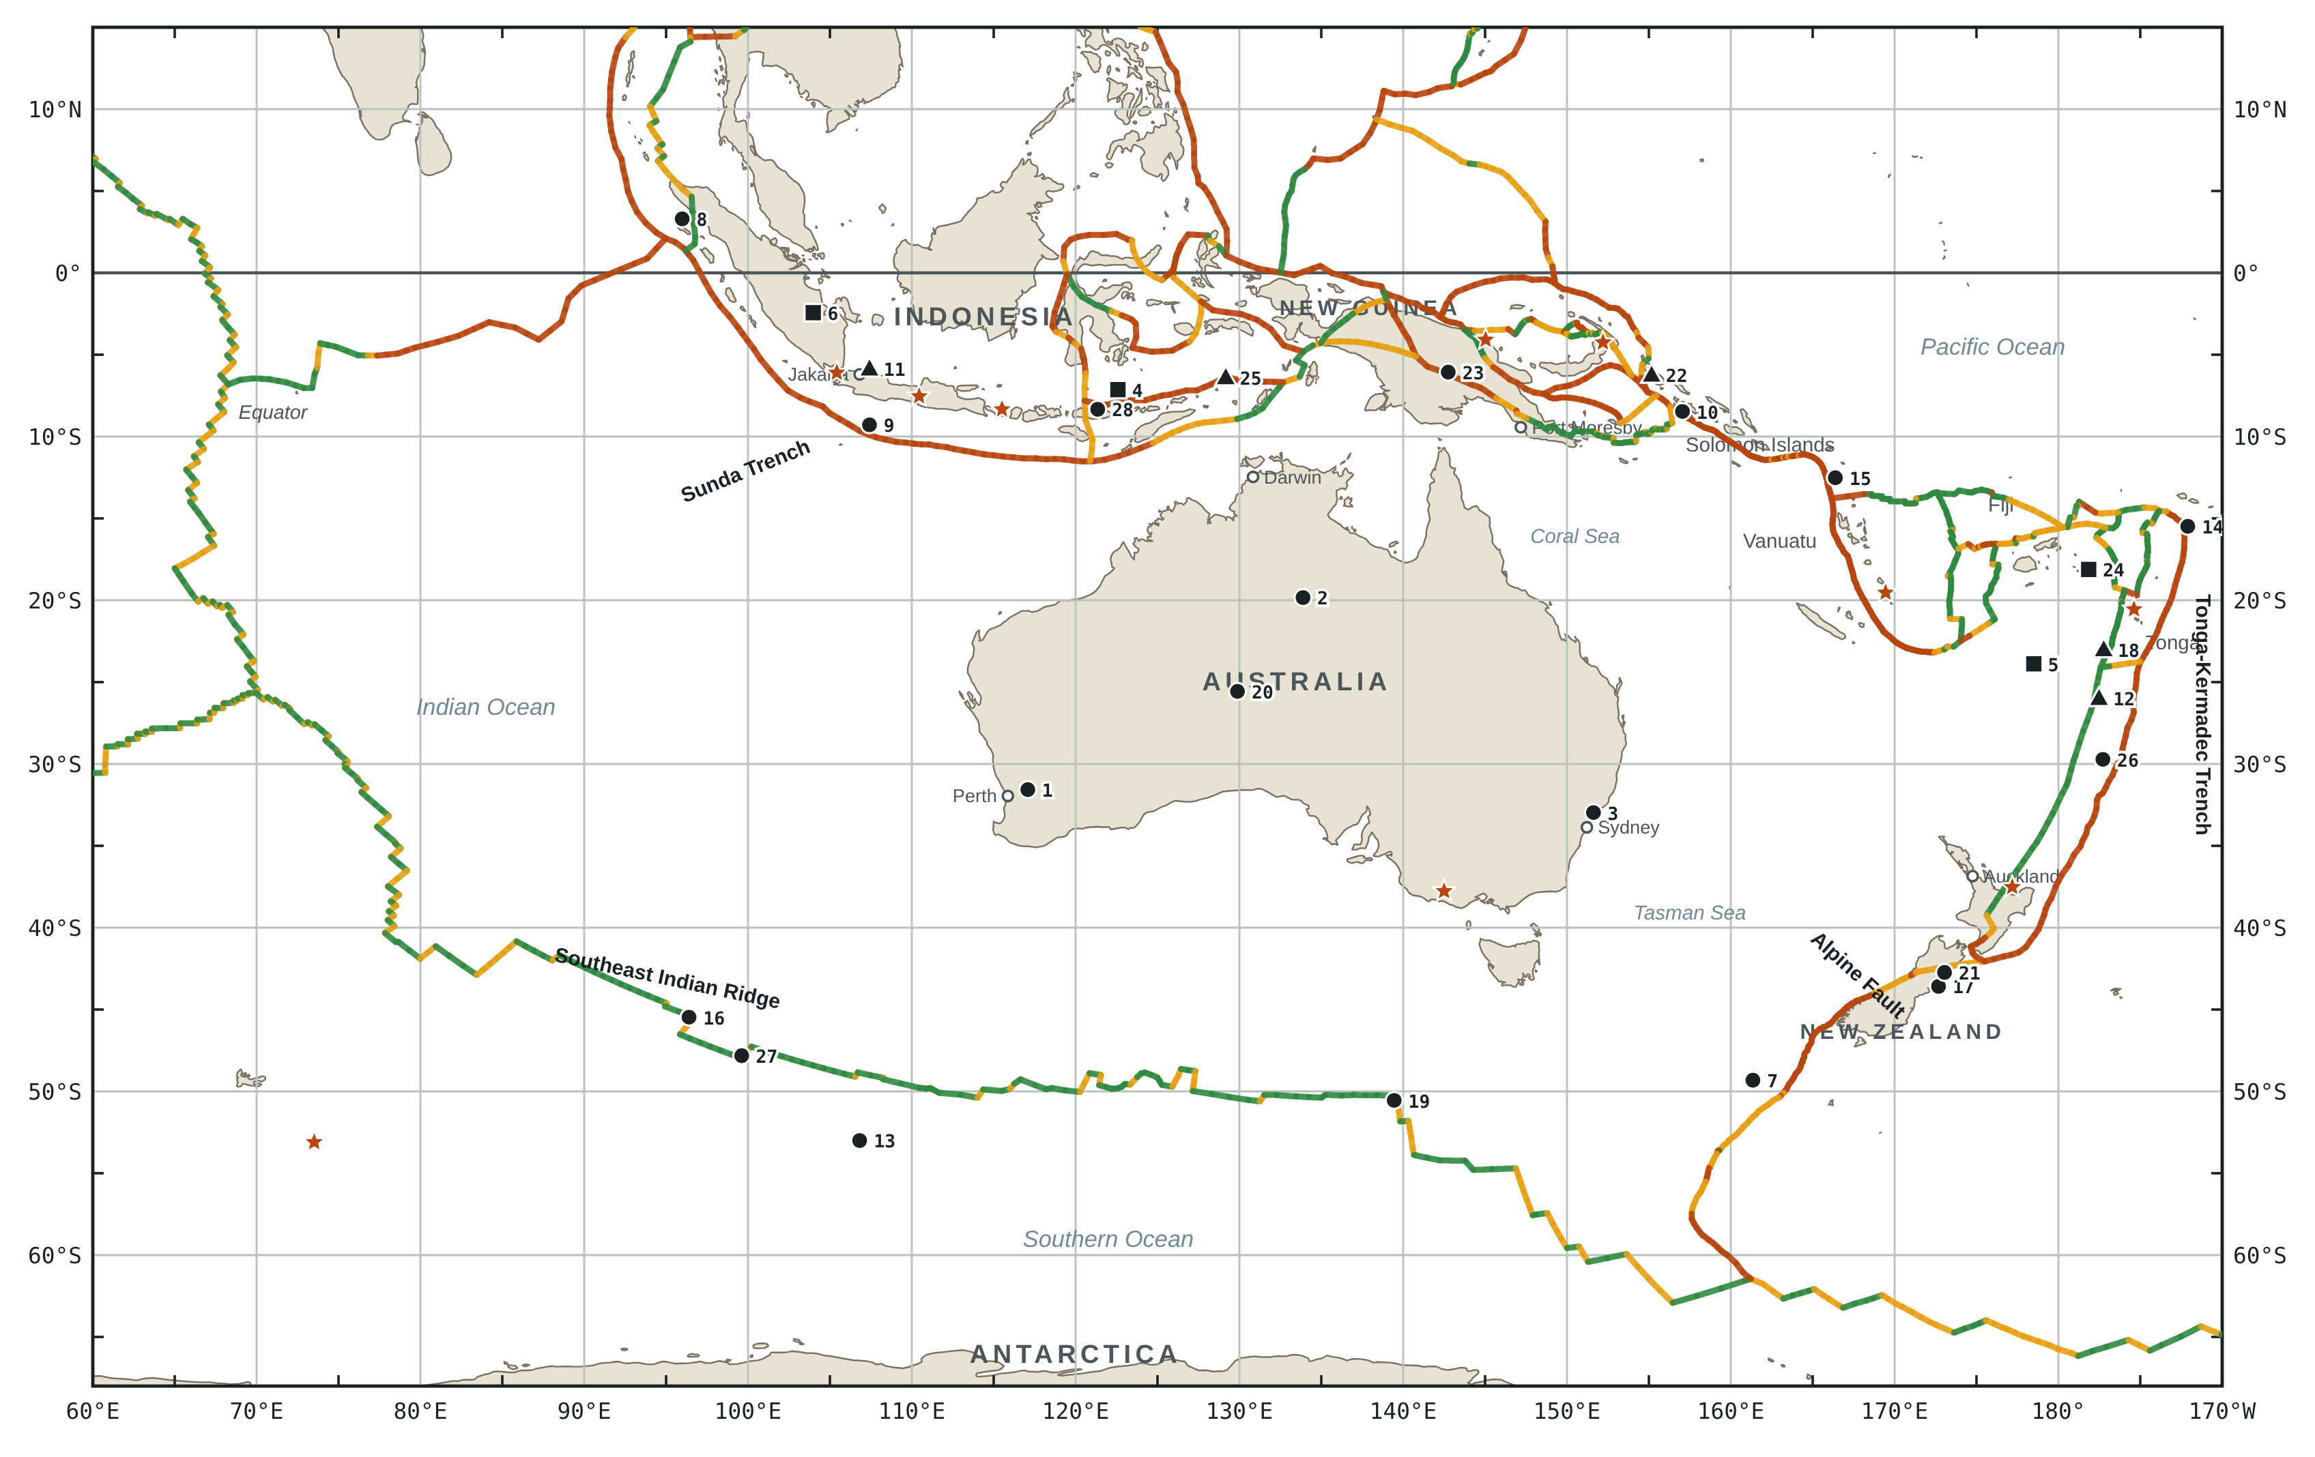
● shallow, 0 to 70 km ▲ intermediate, 70 to 300 km ■ deep, more than 300 km ★ volcano ▬ convergent ▬ transform ▬ divergent

